COMMAND NEXUS CIT 140 WEEK 1

Meridian Forge Evidence Packet
Week 1 Case Materials for Systems Analysis and Design
Use this packet to distinguish what the case records prove from what the investigation still needs to establish. Preserve the source of each statement before you add it to your Problem Brief.
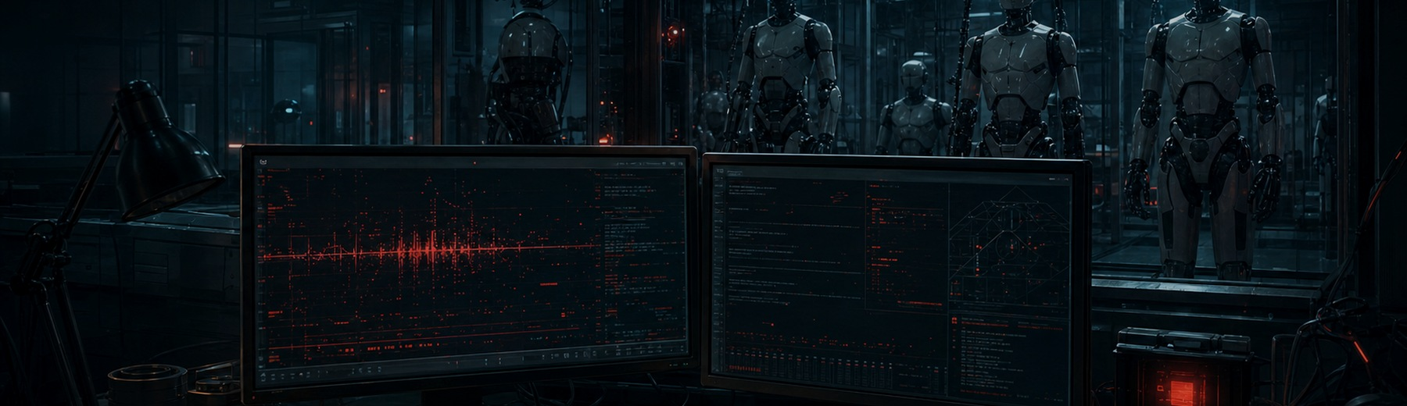
CASE | ORGANIZATION | ARTIFACT
The Process Below | Meridian Forge Robotics | Problem Brief

How to Use the Evidence
Read each record before deciding what it means. A record can support a fact, expose an assumption, or create an investigation question. Do not recommend a repair in Week 1.
Evidence label | Use this label when
Fact | A statement the available source directly supports
Assumption | A claim that extends beyond what the source proves
Question | An unresolved item that requires another record, person, or test

EVIDENCE RECORD 01 QA CELL

Incident Log
SOURCE Nia Voss - Night QA Supervisor
The first record of the repeated test and the stop request that did not stop it.

Recorded Details
Record field | Recorded detail
02:13:07 | MR-17 accepted TEST_K44_START
02:13:09 | The repeat cycle began
02:14:02 | The operator stop request returned ACTIVE_INSTRUCTION_PENDING

Evidence Classification
STATEMENT MR-17 accepted TEST_K44_START at 02:13:07
☐ Fact ☐ Assumption ☐ Question

Analyst Notes
_____Fact. The robot works within the test setting. ___________________________________________________________________________
________________________________________________________________________________
________________________________________________________________________________
________________________________________________________________________________

EVIDENCE RECORD 02 RECORDS TERMINAL

Current Scheduler
SOURCE Current scheduling console
The active scheduling system does not show the test the robot is performing.

Recorded Details
Record field | Recorded detail
Active assignment | MR-17 has no active test assignment
Current catalog | Test K-44 does not appear in the current test catalog

Evidence Classification
STATEMENT Another scheduling service assigned Test K-44 to MR-17
☐ Fact ☐ Assumption ☐ Question

Analyst Notes
_______Assumption. MR-17 should be added. To testing service. Because it is not assigned. ________________________________________________________________________
________________________________________________________________________________
________________________________________________________________________________
________________________________________________________________________________

EVIDENCE RECORD 03 RECORDS TERMINAL

Maintenance Record
SOURCE Maintenance archive
K-44 was retired, but the record does not prove every related service was removed.

Recorded Details
Record field | Recorded detail
Retirement date | Test K-44 was marked retired 186 days before the incident
Recorded action | The record says the test was removed from the active workflow
Unverified scope | The record does not confirm that every copy, service, or schedule was removed

Evidence Classification
STATEMENT Was Test K-44 removed from every service and schedule?
☐ Fact ☐ Assumption ☐ Question

Analyst Notes
________QUESTION. Inquiry as to the status of K-44. What does it have to do with the error? ________________________________________________________________________
________________________________________________________________________________
________________________________________________________________________________
________________________________________________________________________________

EVIDENCE RECORD 04 ENGINEERING STATION

Command Telemetry
SOURCE Elias Chen - Robotics Systems Engineer
The robot received a valid command through an accepted internal interface.

Recorded Details
Record field | Recorded detail
Command format | The command was validly formatted
Source label | legacy_sync.exe
Current limit | The telemetry does not identify the service owner or prove the broader cause

Evidence Classification
STATEMENT legacy_sync.exe caused the entire incident.
☐ Fact ☐ Assumption ☐ Question

Analyst Notes
_______________Assumption. Assumed because K-44 was working and functional before this ._________________________________________________________________
________________________________________________________________________________
________________________________________________________________________________
________________________________________________________________________________

EVIDENCE RECORD 05 OPERATIONS OFFICE

Staff Statements
SOURCE Mara Ilyan - Production Operations Manager
Each person reports a different part of the incident and protects a different operational priority.

Recorded Details
Record field | Recorded detail
Nia Voss | MR-17 behaved normally before the incident
Elias Chen | A controlled restart may clear the active state
Mara Ilyan | Production has paused in the affected QA cell

Evidence Classification
STATEMENT Mara reports that production has paused in the affected QA cell
☐ Fact ☐ Assumption ☐ Question

Analyst Notes
_______Fact_________________________________________________________________________
_________True. She did report as said by Mara. _______________________________________________________________________
________________________________________________________________________________
________________________________________________________________________________

CASE CLOSEOUT

Evidence Review Checklist
☐ I reviewed all five records.
☐ I preserved source names and recorded details.
☐ I separated facts from assumptions.
☐ I recorded questions the evidence does not answer.
☐ I did not recommend a solution in the Week 1 Problem Brief.

Next Action
Return to the Week 1 Nexus assignment. Use these records to complete the Problem Brief, generate the Mission Receipt, and submit the required link and receipt code in Canvas.

